The shelfmark AM 392 fol. is a collection of paper and parchment fragments to which Kristian Kålund continued adding during his time as librarian at the Arnamagnæan Collection. The fragments contain texts in various languages, including Old Norse, Latin, French, and Danish.
Forty-four strips of parchment appear to have originated from a single manuscript in Latin, based on a study of their layout and script. These particular fragments have not been mentioned or identified in previous discussions of AM 392 fol. (Kålund 1889: 303-304, McGuire 1982: 33), though many were held together in a single bundle labelled 11.
During the annual Summer School in Scandinavian Manuscript Studies, which was held in Copenhagen in August 2023, the three authors examined the fragments with the guidance of Tom Lorenz and were able to identify the text of the original manuscript.

Physical description of the fragments
Nineteen of 44 fragments are longer than 400 mm, eight are between 200 and 399 mm, 13 are between 100 and 199 mm, and 6 are less than 99 mm. The majority of the fragments are 18–21 mm wide.
The fragments can be classified as flat or having truncated tips shaped into V-shaped or pointy tips. Approximately one-third, or 15 of these fragments, are flat on both ends. Many bear traces of having been folded longitudinally, suggesting that smaller fragments either were torn from larger pieces along the creases or originated from the same sheet.
The dimensions and form of the fragments do not point to a particular intended use within the collection. While parchment fragments have been found used for binding or reinforcing other manuscripts, none of these fragments have stitching holes and evidence of adhesive is inconsistent. Their shape further does not match the shape the conservators have generally seen for binding materials within the collection.

Script and text
The fragments contain two distinct scripts of different letter sizes which seem to be original to the manuscript. For the original scripts, the larger type fits within 5.5 mm rulings, and the other is written within smaller rulings between 3.5–4.0 mm. There is also a 8–11mm gap between the larger and smaller text.
The use of manicule included in the margins further confirms that the original manuscript likely featured a main text with corresponding gloss apparatus. Particularly in some of the longer fragments, the shape of the gloss text envelops the main text on all sides. This spatial arrangement suggests that the manuscript was at least a bifolio. The line counts for the main text and glosses vary, further segmented as follows:
- Main text: 46–51 lines
- Side gloss: 92–116 lines
  - Upper gloss (above main text): 7–10 lines
  - Lower gloss (under main text): 23–32 lines
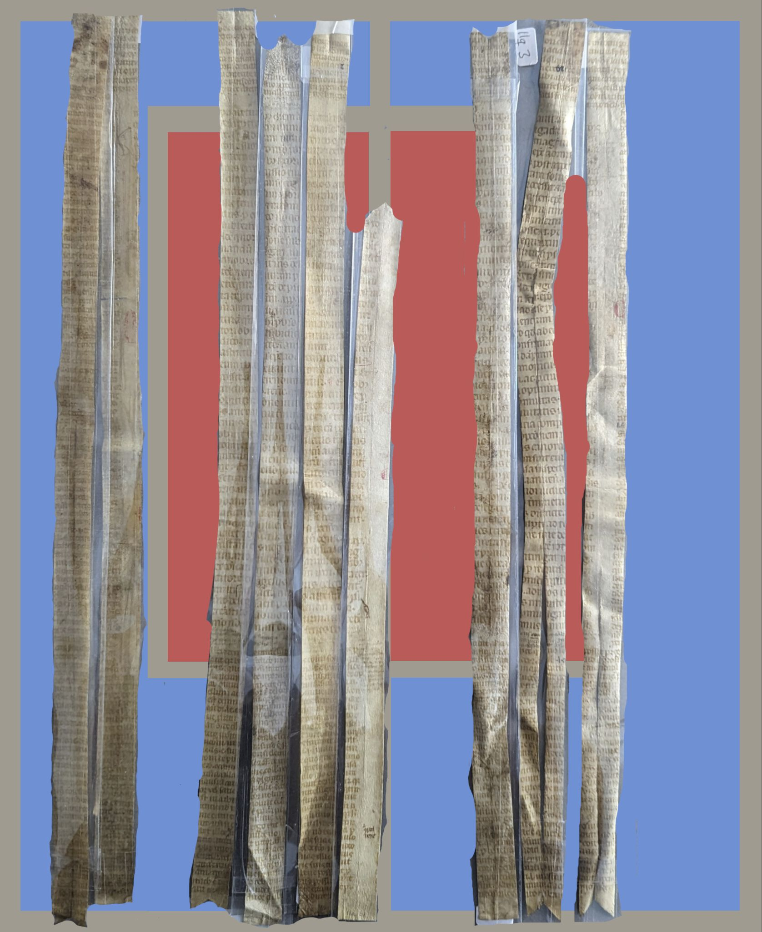
(Image 1: Reconstruction of the original manuscript)
Other surface features such as rubrication, ruling (only in the main body), reference signs, and post hoc corrections in a different ink are also noteworthy and serve as keys to reconstituting the shape of the original manuscript. The layout featuring a central main text surrounded by glosses is commonly observed in texts pertaining to ecclesiastical and legal matters. By close study of words in the fragments, the text was identified as Decretales Gregorii IX, a thirteenth-century canon law.
Further collation with the printed edition of the text from 1558 enables a more granular text comparison, shedding light on the number of sheets initially involved. Ultimately, a single folio of this size could yield up to 15 large fragments.
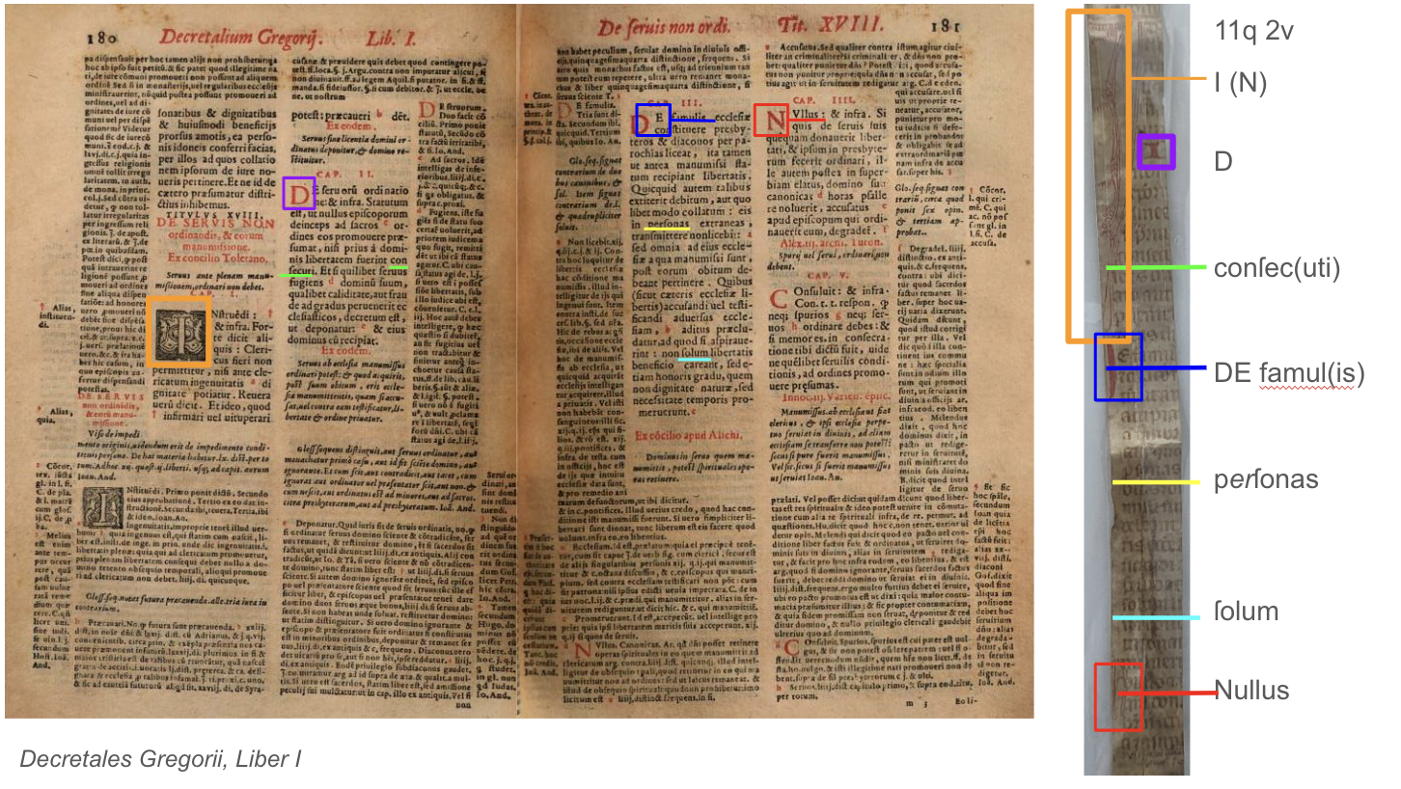
Palaeographic considerations, including multiple forms of 'a' (a with lobe and single-compartment a), 's' (round s and long s), 'r' (regular r or r rotunda) and distinctive letters like 'd,' 'g,' 'f,' along with flourishes, suggest a possible affinity to the southern continental writing milieu, possibly Italian and dated ca. 14th century.
However, the acquisition of the manuscript by Árni Magnússon and its eventual inclusion in AM 392 fol. remain nebulous. Given the large sizes of the fragments, the lack of stitching holes and the possible presence of glue on some ends, these fragments might have been prepared for use as seal strips for charters but probably were never actually utilized as such. Smaller fragments, on the other hand, could have served alternate purposes, perhaps as bookmarks.
Examining understudied manuscript fragments serves not only to elucidate the texts they contain but also to shed light on the historical and cultural valuation ascribed to the texts and manuscripts themselves. The fragments housed in AM 392 fol. undoubtedly constitute an instance of such significance, with the potential to provide novel perspectives on the text and manuscript environment within the Arnamagnæan manuscript collection.

McGuire, Brian Patrick. (1982). The Cistercians in Denmark: Their attitudes, roles and functions in medieval society. Kalamazoo: Cistercian Publications.
Kålund, Kristian. (1889). Katalog over den Arnamagnæanske håndskriftsamling, vol. 1. Copenhagen: Gyldendal.

Gregor IX. Decretales Gregorii noni pontificis : cum epitomis, divisionibus & glossis ordinariis, una cum additionibus novissime recognitae, & infinitis prope mendis purgatae studio & industria clarissimi iureconsulti ... expunctis ... Lugduni: a Porta & Vincentius, 1558. [Elektronische Reproduktion, München]

